

**NAMA : SHABRINA QOTTRUNNADA**

**NIM : 2341760160**

**KELAS : 1G**

**MATERI : Pseudocode and Flowchart (Jobsheet 4)**

**EXPERIMENT 3**

Question!

1. Modify the pseudocode and flowchart above by adding user input for bookBrand and pageCount, then change the discount to get the user input as well!

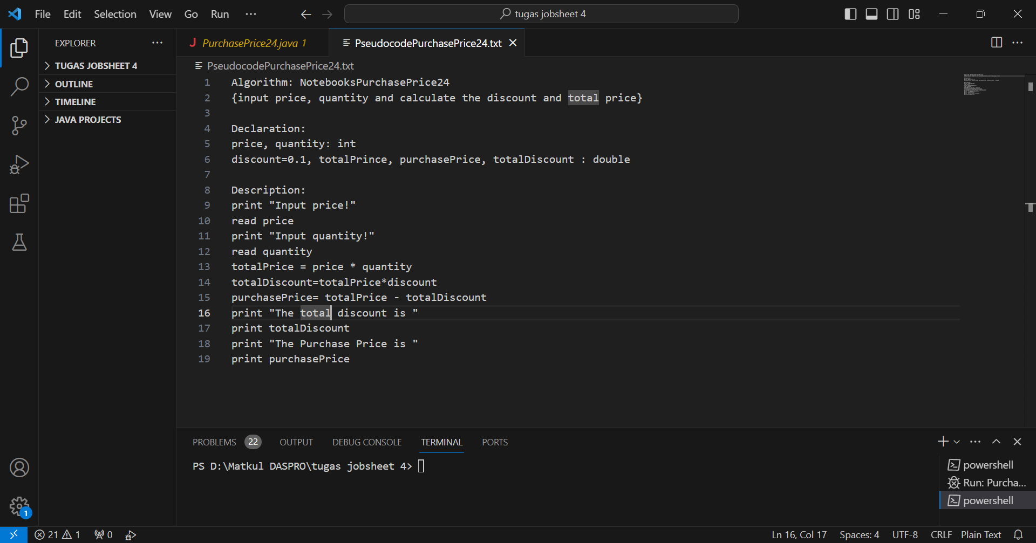

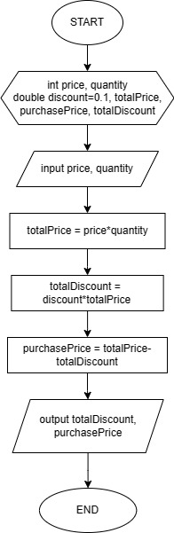

1. Implement the changes in a program!

